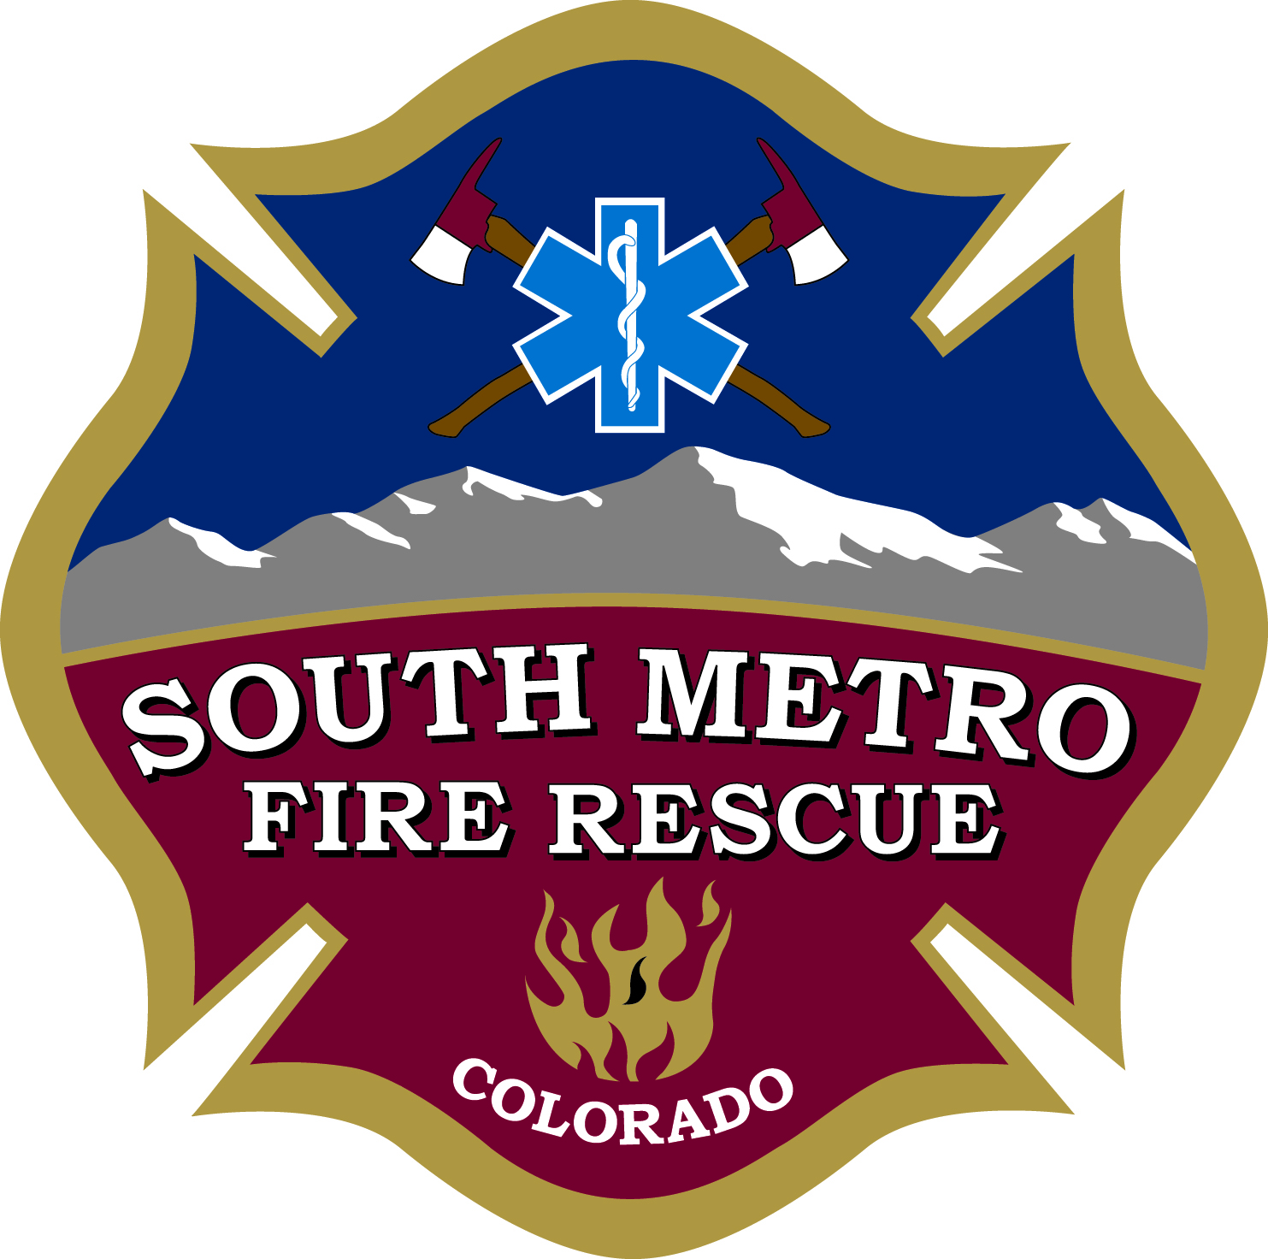
South Metro Fire Rescue
Community Room Use Agreement
Terms and Conditions

- Community Room Users are expected to reasonably clean up rooms after use and return the room to original set-up and condition. In the event damage occurs or the facility is not cleaned to the satisfaction of the SMFR at the time of final inspection, the Lessee shall be responsible for all costs associated with damage to or cleaning of the premises, including all costs and expenses of collection and enforcement, including attorney fees. The User will be charged a damage/cleaning fee of $100.00 or actual costs, whichever is greater.

- General cleaning and use guidelines include:

  - Trash: Please bag up trash for removal. Trash will be picked up by cleaning crew at Mineral HQ during the week. On weekends at Mineral HQ, please bring trash to bins located on the west side of the parking lot.
  - Vacuum and cleaning supplies are available on site for the all locations.
  - When using lower level Meeting Rooms 1 & 2 at Mineral HQ, groups shall not open or close partitions between the rooms. SMFR staff will provide this service if necessary.
  - Should you need help in setting up for the use of microphones or overhead projectors in the Mineral locations you will need to contact our Technical Services Bureau no later than one week before you need to room to schedule IT help by calling 720-989-2440. IT assistance is only available by appointment and during normal working hours (7:30 am to 4:30 PM).
  - SMFR does not provide personnel to assist in handling exhibits and other materials needed by groups using a meeting room.
  - Parking by community room users shall not block access to fire stations or block the station’s functionality. Additional parking at the Mineral HQ building is available on the third floor of the parking garage.
  - Should you experience difficulty in accessing a location after hours (hours of operation are 7:30-4:30 Monday – Friday) please call the after-hours IT Help Desk number at 720-989-2440. You will be required to leave a message and the on-call person will call you back.

- For the duration of the approved use, the User is responsible for all accidents, injuries, damages, or loss of property. The User shall indemnify and hold harmless SMFR and its designated representatives from any and all claims resulting from the use of the facility. The User may be required to have and present a certificate of insurance in the amount and terms specified by SMFR, with SMFR listed as an additional insured.

[Government entities only] For the duration of the approved use, the User is responsible for all accidents, injuries, damages, or loss of property. The User may be required to present a certificate of insurance demonstrating that it maintains commercial general liability and property damage insurance, with SMFR listed as an additional insured.

- The User shall provide proper supervision ensuring the protection of persons and property in its care including the leased facility, the adherence of facility and SMFR rules, regulations, ordinances, and occupancy rates and the restriction of all participants to the authorized areas only. Room use must be under the direct supervision of the person making the reservation or their designated representative.

- Use of these facilities is restricted to appropriate not-for-profit organizations or community groups for meetings only. User must be located in or a resident of SMFR’s District.

- The User shall not allow the operation of any commercial concessions nor allow the imposition of any charge or request a donation of any kind to be made of the public on the leased facility without prior SMFR approval.

- SMFR reserves the right to limit, edit, or disallow any programs, circulars, pamphlets, or other forms of advertisement using SMFR identification.

- User shall not assign its space or reservation to another group.

- Hours of room availability are from 7:00 AM to 9:30 PM daily. Special arrangements may be made for extensions of the room availability time. SMFR has the right to limit the number of hours an organization can use the meeting room facilities. In no way will use of the community room interfere with the function of the fire station or other facility.

- Smoking, gambling, use or possession of alcoholic beverages, marijuana, and illegal drug use on SMFR premises are all prohibited. The use of open flames or candles in meeting rooms is prohibited. Users are expected to follow all applicable local and federal laws as well as current fire code.

- The possession or use of concealed or unconcealed weapons on District property is prohibited regardless of whether or not the person is licensed to carry the weapon, with the exception of P.O.S.T. certified law enforcement professionals and as otherwise permitted in SMFR Board Resolution 22-06 or other written agreement with SMFR.

- SMFR will not provide promotional assistance, materials or services for any programs not sponsored by SMFR. This includes but is not limited to photocopying of program materials, creation of posters or other materials, electronic postings on social or networking web sites, answering telephone questions from attendees about scheduled events, or e-mail assistance.

- Cancellations:
  - SMFR reserves the right to cancel this agreement and withdraw the permissions hereby granted for just cause, for failure to comply with any of the foregoing, or for falsification or misrepresentation of information submitted to SMFR. In such cases, the User will, upon request, immediately remove all persons and equipment from the reserved facility.
  - SMFR reserves the right to require the User to alter or cancel the leased period for a SMFR/Civic activity, a SMFR holiday, a partial/full facility shut down, or for reasons SMFR deems it necessary.
  - Reservations must be cancelled at least 24 hours prior to the reservation. If a group does not use a reservation twice in a row without canceling at least 24 hours in advance, SMFR reserves the right to cancel their future reservations.

SMFR Contact Information
South Metro Fire Rescue
9195 East Mineral Avenue
Centennial, CO 80112
Phone: 720-989-2000
Email: roomreservation@southmetro.org

